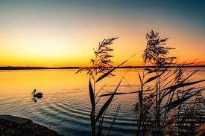

**Nature is the ultimate source of our living**. Both living and non-living things include nature, and everyone is interdependent, which helps maintain the ecosystem. Plants, animals, and humans all depend on nature for their survival. It supplies oxygen, sunlight, soil, water, and other necessary components.

.[[](https://en.wikipedia.org/wiki/Natural_landscape#cite_note-6)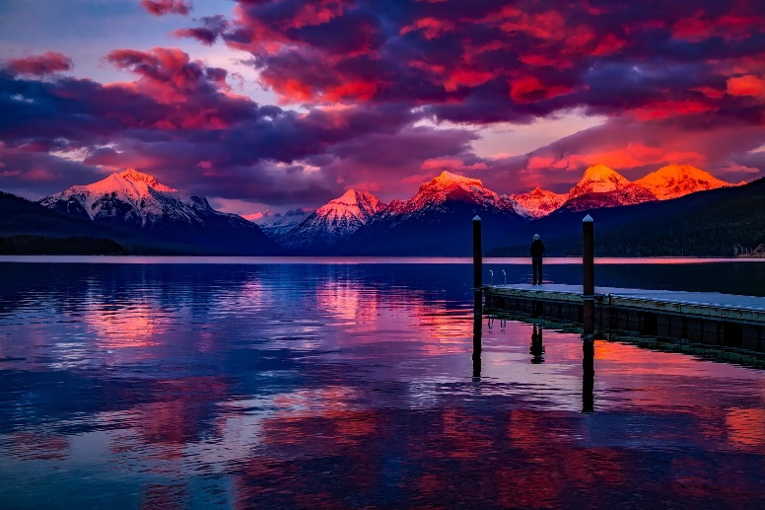

A **natural landscape** is the original [landscape](https://en.wikipedia.org/wiki/Landscape) that exists before it is acted upon by [human culture](https://en.wikipedia.org/wiki/Human_impact_on_the_environment).[ 1The natural landscape and the [cultural landscape](https://en.wikipedia.org/wiki/Cultural_landscape) are separate parts of the landscape.[ However, in the 21st century, landscapes that are totally untouched by [human activity](https://en.wikipedia.org/wiki/Human_behavior) no longer exist,[so that reference is sometimes now made to degrees of naturalness within a landscape.[[](https://en.wikipedia.org/wiki/Natural_landscape#cite_note-6)